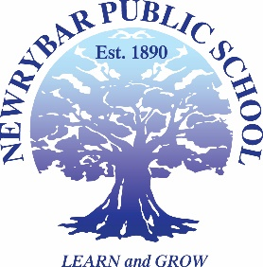
Newrybar Public School
10 Broken Head Rd, NEWRYBAR NSW 2479 Phone: 6687 1343 Fax: 6687 2072
newrybar-p.school@det.nsw.edu.au

PERMISSION NOTE
Headlands District Cross Country
(Friday 18th May, 2018)

I give permission for my child…………………………………………………………………………… to participate in the District Cross Country at Teven Tintenbar Primary School on Friday 18th May 2018.
I understand that transport is the responsibility of the parent.
- I will be transporting my own child to the District Cross Country
- I will be transporting _________________
- I confirm that I have arranged transport for my child with ___________________
By signing this form I also acknowledge my responsibility to;
- hold a current driver’s license,
- drive a vehicle with current registration and
- abide by the RMS recommendation to seat children 13 and under in the back seat if a front seat airbag exists.
If I have organised transport for my child I take the responsibility to ensure my chosen transporter abides by the afore mentioned regulations.

Signed ………………………………………… Date ………………………………….
Parent/ Guardian

Please return permission by no later than Tuesday 15th May, thank you

